HACKATHON PROJECT

**IDENTIFY NEW BIKES**

(Suggested Website : [www.zigwheels.com)](http://www.zigwheels.com))

Prepared By-

HackOverflow (Team-6)

Ankit Dey (891114)

Puja Sarkar (891144)

Chandranibha Ray (891170)

Pawan Kumar (891172)

**TABLE OF CONTENTS**

|  |  |  |
| --- | --- | --- |
| Serial NO. | Topics | Page NO. |
| 1. | Introduction | 03 |
| 1.1 | Intended Audience | 03 |
| 1.2 | Project Scope | 03 |
| 2 | Overall Description | 03 |
| 2.1 | Operating Environment | 03 |
| 3 | Requirements | 04-08 |
| 3.1 | Description | 04 |
| 3.2 | Functional Requirements | 04-08 |

**1.INTRODUCTION**

Zigwheels is an automotive and motorcycling website based in India. We are taking and testing three functionality of that website (i.e.)  Selecting New bikes(Upcoming Honda Bikes),Selecting Used Cars in Chennai and Login with invalid details.

**1.1 Intended Audience**

* Business Unit (BU) SME
* Academy coach
* Technical Trainer

**1.2 Project Scope**

This document defines at a functional level the business activities that are encompassed by the system and the rules that apply to them. It also encompasses some of the key high and low level technical requirements of the system.

It draws heavily on both proposed Framework and Business Rules and the Technical Architecture documents. The scope of the detailed analysis project phase specifies that this document will include.

* Classification of requirements according to their functional areas.
* A description of each process in the system, including their inputs, outputs, and data transformation rules.

**2. Overall Description**

**2.1 Operating Environment**

* Windows operating system
* Web application

**3. Requirements**

**3.1 Description**

This part of the requirements document serves to present the "ZigWheels for New Bikes" and " ZigWheels for Used Cars”, and “ZigWheels for Invalid Login” functionalities of the application.

* 1. **Functional Requirements**

**3.2.1 Req0001**

Req0001a-Mouse Hover to “New Bikes”.

Req0001b-Click on “Upcoming Bikes”.

Req0001c-Click on “Select Manufacturer”.

Req0001d-Scroll down and click on “View More Bikes”.

Req0001e-Print all the Honda Bikes models, price, launch dates under Rs 4lakhs.

Req0001f-Scroll to top.

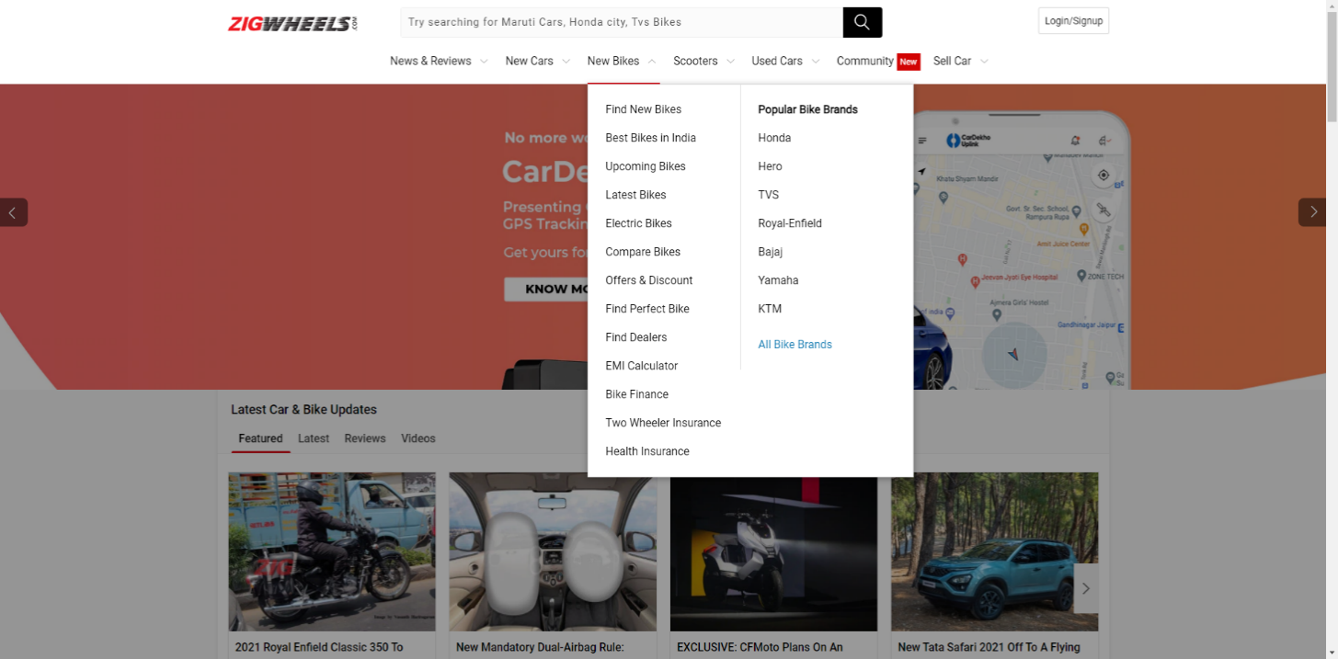

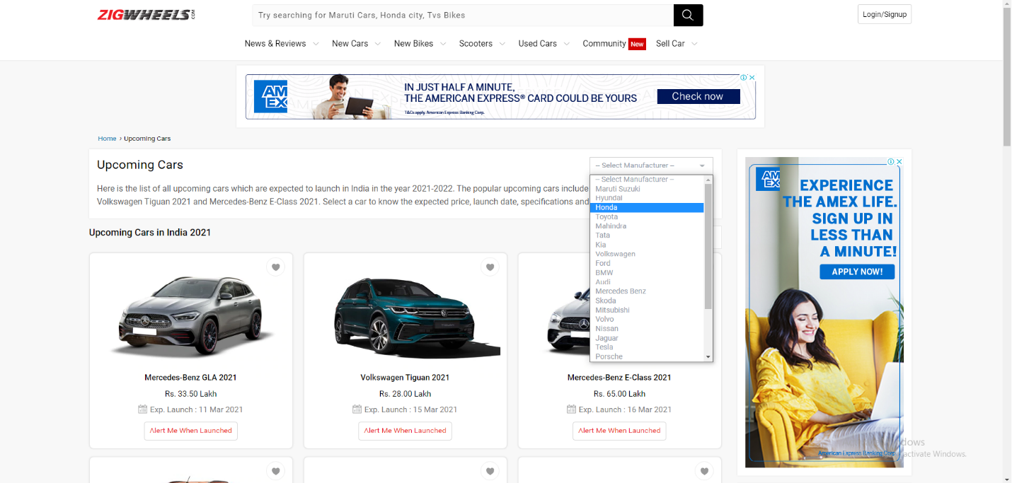

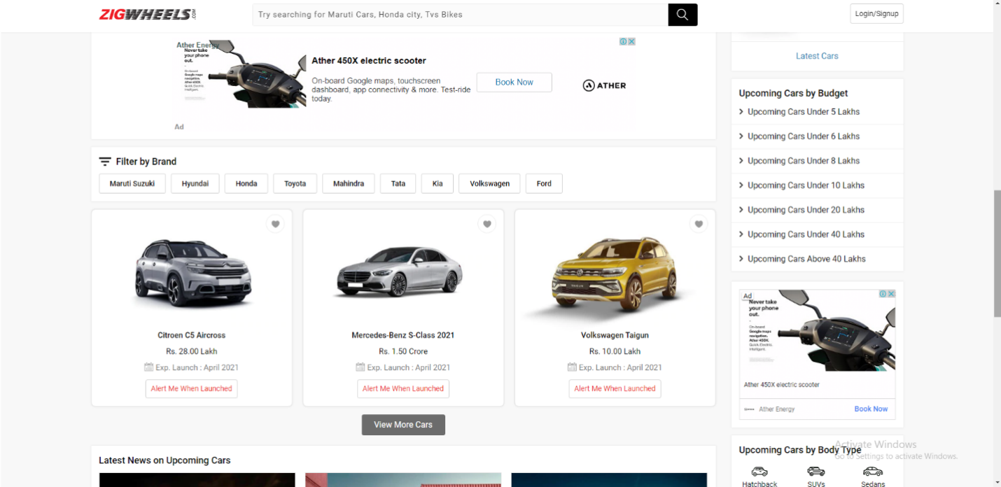

**3.2.2 Req0002**

Req0002a-Mouse Hover to “Used Cars”.

Req0002b-Click on “Chennai”.

Req0002c-Scroll down and print all “Popular Models” cars.

Req0002d-Go to home page by clicking on “ZigWheels” logo.

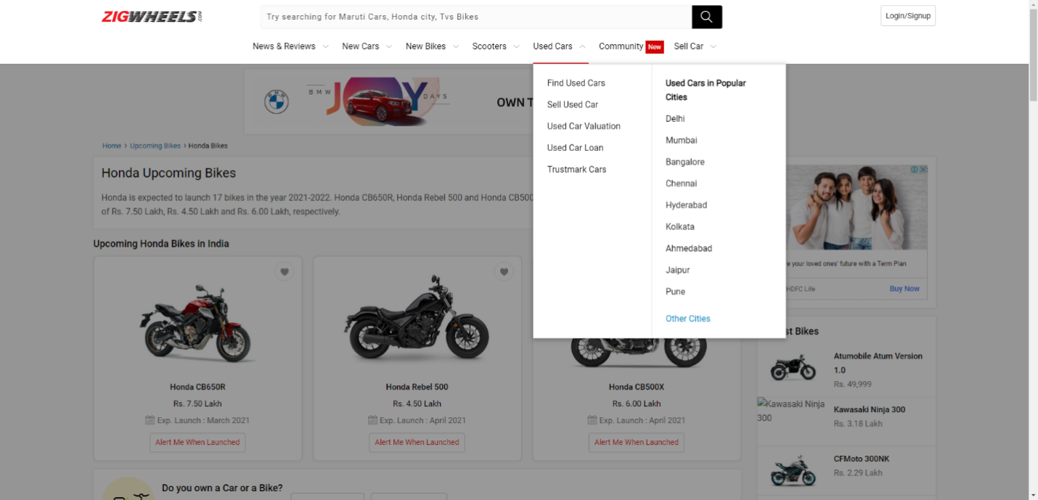

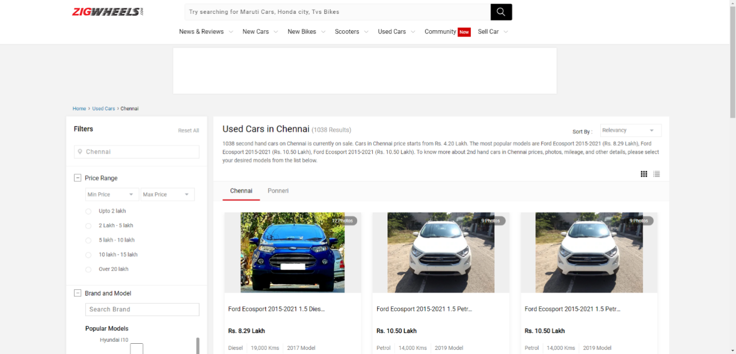

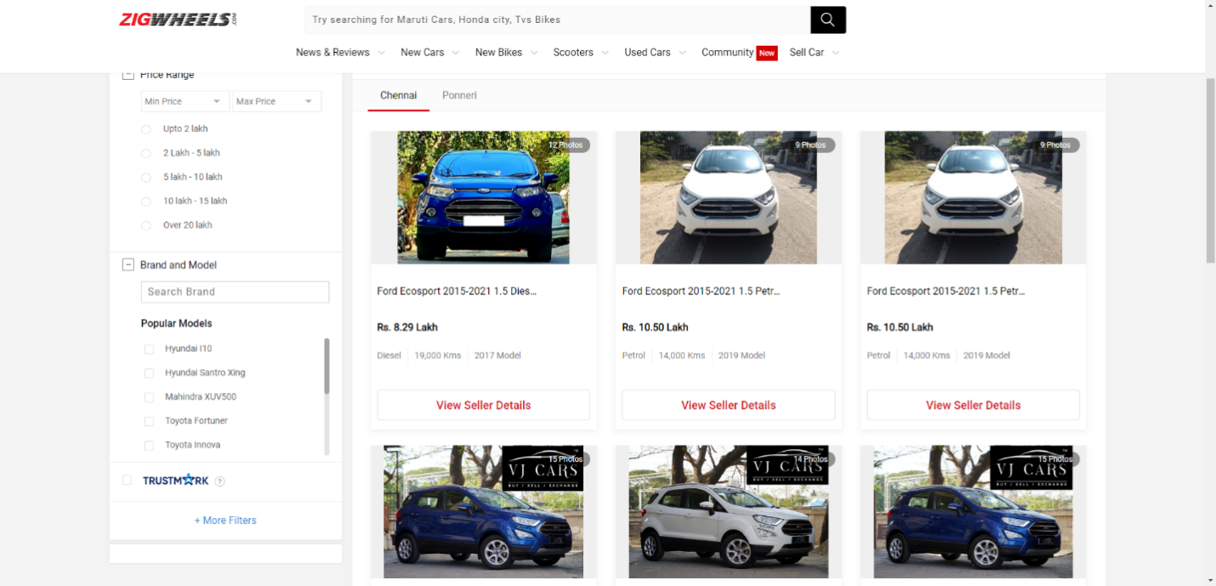

**3.2.3 Req0003**

Req0003a- In home page of ZigWheels, click on “Login”.

Req0003b- Click on “Continue with Google”.

Req0003c- Enter invalid email and click on “Next”.It will show an error “Couldn’t find your Google Account”.

